**HOW TO CREATE A VPC**

How To Separate Public Server And Private Server Is Using To Route tables.

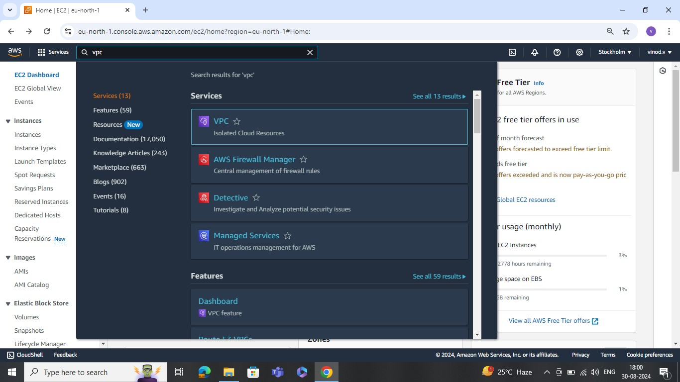

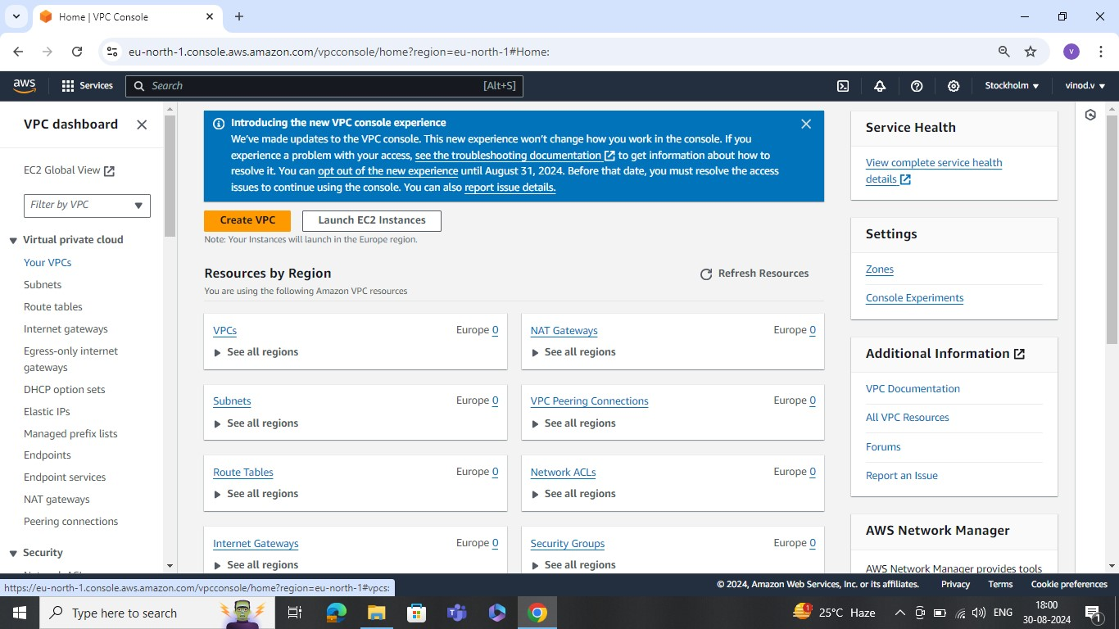

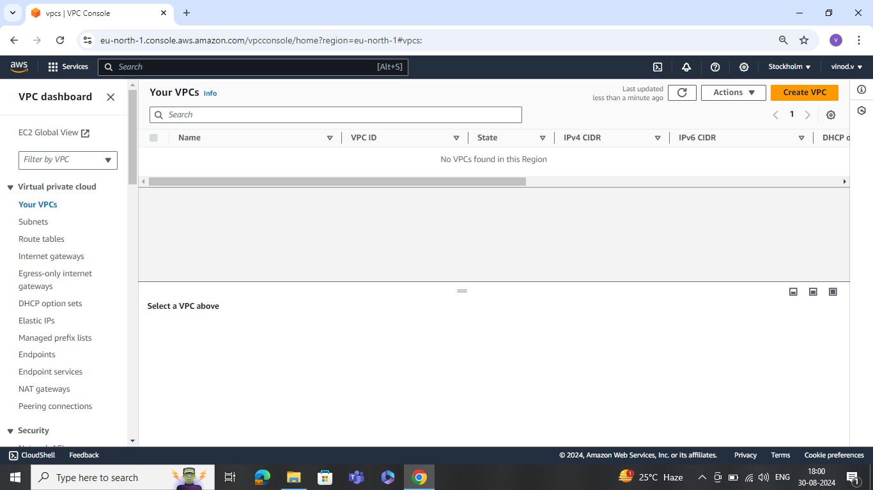

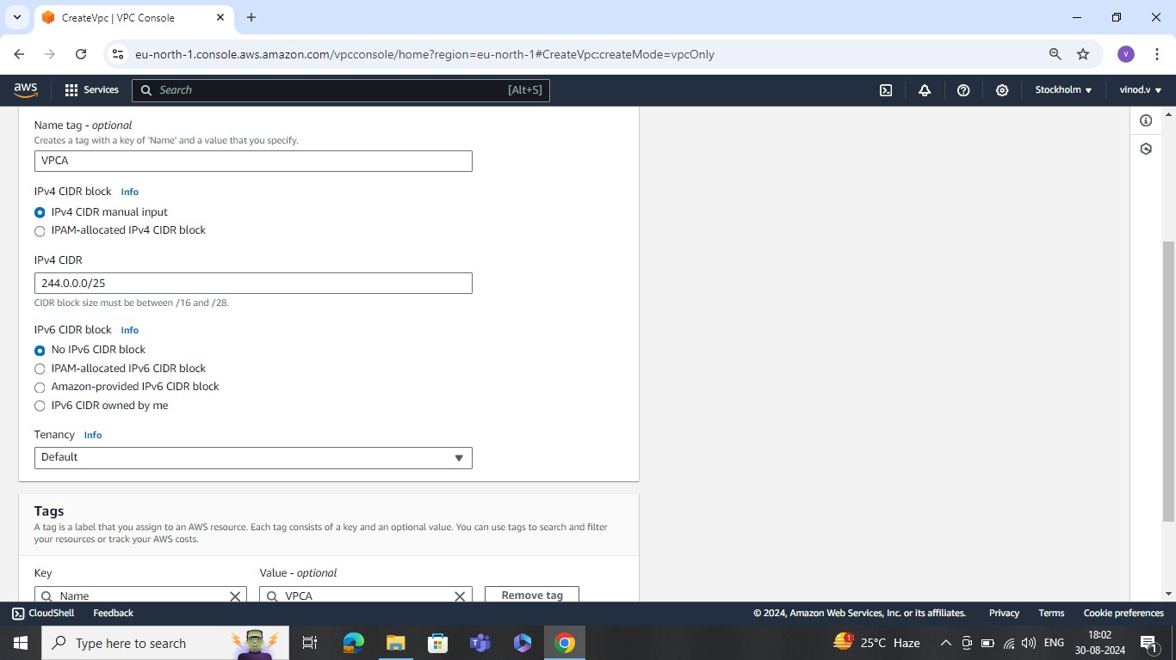

Availability Zones Are Public Subnet And Private Subnet.Routes tables only will allows the any trafic.

(like: Internet,NAT)

**VPC Creation Process:**

**stp1**: Go to Your VPCs

**stp2**: After Create Vpc

**stp3: Vpc Settinges**

**. Resources to create**

.vpc only . vpc and more

**step4:** Name tag-optional

VpcA -> **write this**

**stp5:** Ipv4 CIDR block

.Ipv4 CIDR manual input

.IPAM -allocate ipv4 CIDR block

**IPV4 CIDR**

244.0.0.0/25 -> **write this**

**NOTE:** CIDR block size must be b/w/16 and/28

MAX is 16 MIN is 28

**step6:** Create vpc click After vpc was created successfully

**step7:** Go to Route table **( it shows default routetable only for chekbased)**

**step8:** Go to Create a Network Acls **(chek based)**

This is publicsubnet1

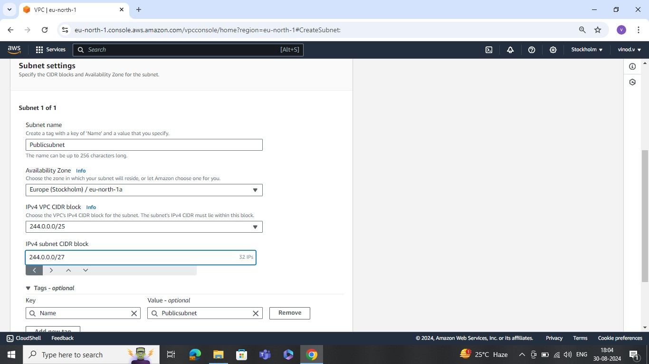

Privatesubnet2

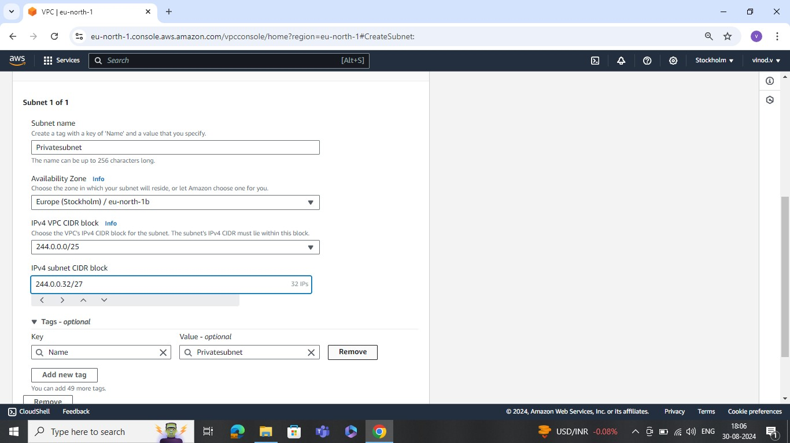

**step9:** After go to the Subnet services (Create sbunet)

.VPC

VPC ID

Create Subnet in this pc

Vpc-0750ea5ed6ddc355(vpca) -> **write this one**

**(Create) #Click**

**step10:** Go to the sunet 1 OF 1 -> In settings

Subnet Name

PUblicsubnet -> **write**

. Availablity Zone:

us East(n.virginia)/us-east-1a ->write

. IPV4 subnet CIDR block

244.0.0.0/27 -> **write**

(**create)**

**stp11:** And also one more create a Private subnet

Here Change the IPV4 subnet CIDR block

244.0.0.32/27

**(create)**

**stp12:** Go to the internet gatways create one

wtite the Name Tag

internet -> write

(create internet gatway)

**stp13:** We Need to Attach to a VPC

After to vpc

vpc

Avilable Vpcs

Vpc-------- -> write and fill some thing

(Attach internet gate way)

NOTE: We need to Attach to the route tables then only it will allows

**step14:** After go to the Route tables

. Select one Route table

. After go the Routes

. Edit routes

. And add the route botam one click

. go to target write the INTERNET GATEWAY and come down Write the some thing

(Save the changes)

**step15**: One more create Route Table

Step16: After Creation process done Go to the route tables

1> Selecte one route table

2> go to the subnet associations

(Edit Subnet Associations)

3> Edit the subnet Associations check

4> And Available Subnets

public --> Select this one

private

(Save association)

**step17:** Same Process do the Private also in the Route tables.

**step18:** Go to the instances After lunch instances private and public.

1> Public server lunch process Subnet was PUblic subnet And Auto Assign public IP was Enable write.

2> private server lunch process subnet was Private subnet And Auto Assign Private IP was Disable write.

(Launch instances)

step19: Select one Instance And Connet to the server

1> After connect to the public srver we can directly able to the acess

Using Some Comands:

-> sudo su -

ll

-> yum install git -y

->> After using those all comands was connect the private server in the process of public get the out put

-> vi keypairc15.pem

-> :wq! (this used for saved purpose)

-> Chmod 400 "keypair15.pem"

-> Shh-i "keypair 15.pem"ecl user@244.0.0.55

-> yes

2> But private server was not like that we go to the SSH process in private server.

Some Of The Steps In How To Connect Private server:

1> So We go to the SSH Client

2> And copy the "Keypair ----"

3> When Keypair save the Note pad one copy and paste the Running of the process in public using some of the commmands.

4>We need used the Chmod 400 "keypair15.pem"

5> Shh-i "keypair 15.pem"ecl user@244.0.0.55

**step20:** Go to VPcs for the provide the internet in the private server

(**create NAT Gateway)**

1> NAT Gatway

Name: NAT Gateway

subnet:public subnet (click one)

Elastic ip allocation : ---- ( Allocate Elastic)#click

(**crate NAT Gateway)**

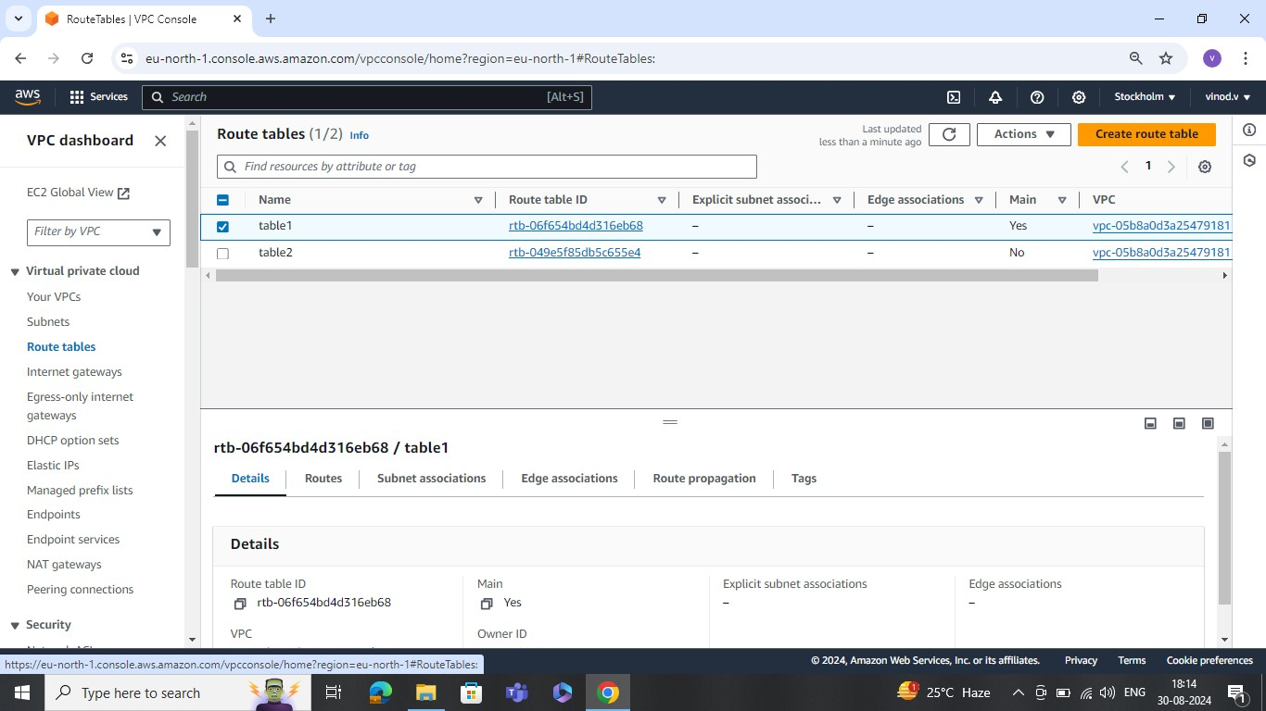

**step21:** After go to the route tables

Select one

After Go to the Routes **(Edit Routes)**

Edit routes

NAT Gatway ( write)

---------(fill this and write)

(ADD rule) **#click**

**(save the cahnges)**

Open server and connect the public servers

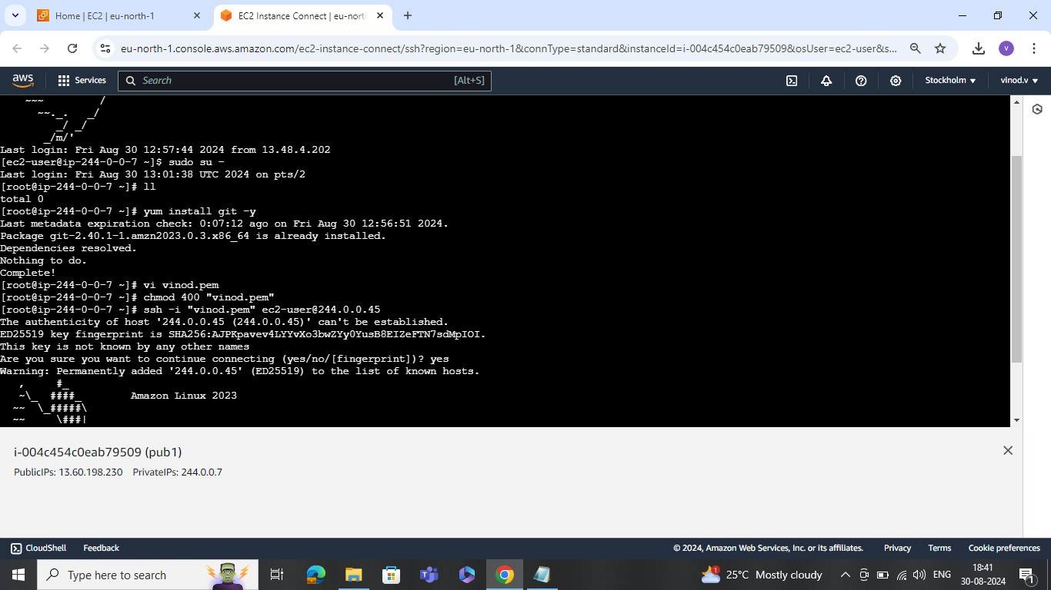

**use for comandas public server to private server connect process:**

Last login: Fri Aug 30 12:57:44 2024 from 13.48.4.202

[ec2-user@ip-244-0-0-7 ~]$ sudo su -

Last login: Fri Aug 30 13:01:38 UTC 2024 on pts/2

[root@ip-244-0-0-7 ~]# ll

total 0

[root@ip-244-0-0-7 ~]# yum install git -y

Last metadata expiration check: 0:07:12 ago on Fri Aug 30 12:56:51 2024.

Package git-2.40.1-1.amzn2023.0.3.x86_64 is already installed.

Dependencies resolved.

Nothing to do.

Complete!

[root@ip-244-0-0-7 ~]# vi vinod.pem

[root@ip-244-0-0-7 ~]# chmod 400 "vinod.pem"

[root@ip-244-0-0-7 ~]# ssh -i "vinod.pem" ec2-user@244.0.0.45

The authenticity of host '244.0.0.45 (244.0.0.45)' can't be established.

ED25519 key fingerprint is SHA256:AJPKpavev4LYYvXo3bwZYy0YusB8EIZeFTN7sdMpIOI.

This key is not known by any other names

Are you sure you want to continue connecting (yes/no/[fingerprint])? yes

Warning: Permanently added '244.0.0.45' (ED25519) to the list of known hosts.

, #_

~\_ ####_ Amazon Linux 2023

~~ \_#####\

~~ \###|

~~ \#/ ___ https://aws.amazon.com/linux/amazon-linux-2023

~~ V~' '->

~~~ /

~~._. _/

_/ _/

_/m/'

[ec2-user@ip-244-0-0-45 ~]$ sudo su -

[root@ip-244-0-0-45 ~]# yum install nginx

Amazon Linux 2023 repository 103 kB/s | 27 MB 04:30

Amazon Linux 2023 Kernel Livepatch repository 57 kB/s | 11 kB 00:00

Dependencies resolved.

==================================================================================================================================================================

Package Architecture Version Repository Size

==================================================================================================================================================================

Installing:

nginx x86_64 1:1.24.0-1.amzn2023.0.2 amazonlinux 32 k

Installing dependencies:

generic-logos-httpd noarch 18.0.0-12.amzn2023.0.3 amazonlinux 19 k

gperftools-libs x86_64 2.9.1-1.amzn2023.0.3 amazonlinux 308 k

libunwind x86_64 1.4.0-5.amzn2023.0.2 amazonlinux 66 k

nginx-core x86_64 1:1.24.0-1.amzn2023.0.2 amazonlinux 586 k

nginx-filesystem noarch 1:1.24.0-1.amzn2023.0.2 amazonlinux 9.1 k

nginx-mimetypes noarch 2.1.49-3.amzn2023.0.3 amazonlinux 21 k

Transaction Summary

==================================================================================================================================================================

Install 7 Packages

Total download size: 1.0 M

Installed size: 3.4 M

Is this ok [y/N]: yes

Downloading Packages:

(1/7): generic-logos-httpd-18.0.0-12.amzn2023.0.3.noarch.rpm 311 kB/s | 19 kB 00:00

(2/7): libunwind-1.4.0-5.amzn2023.0.2.x86_64.rpm 981 kB/s | 66 kB 00:00

(3/7): nginx-1.24.0-1.amzn2023.0.2.x86_64.rpm 1.6 MB/s | 32 kB 00:00

(4/7): gperftools-libs-2.9.1-1.amzn2023.0.3.x86_64.rpm 3.4 MB/s | 308 kB 00:00

(5/7): nginx-core-1.24.0-1.amzn2023.0.2.x86_64.rpm 17 MB/s | 586 kB 00:00

(6/7): nginx-filesystem-1.24.0-1.amzn2023.0.2.noarch.rpm 424 kB/s | 9.1 kB 00:00

(7/7): nginx-mimetypes-2.1.49-3.amzn2023.0.3.noarch.rpm 930 kB/s | 21 kB 00:00

------------------------------------------------------------------------------------------------------------------------------------------------------------------

Total 4.6 MB/s | 1.0 MB 00:00

Running transaction check

Transaction check succeeded.

Running transaction test

Transaction test succeeded.

Running transaction

Preparing : 1/1

Running scriptlet: nginx-filesystem-1:1.24.0-1.amzn2023.0.2.noarch 1/7

Installing : nginx-filesystem-1:1.24.0-1.amzn2023.0.2.noarch 1/7

Installing : nginx-mimetypes-2.1.49-3.amzn2023.0.3.noarch 2/7

Installing : libunwind-1.4.0-5.amzn2023.0.2.x86_64 3/7

Installing : gperftools-libs-2.9.1-1.amzn2023.0.3.x86_64 4/7

Installing : nginx-core-1:1.24.0-1.amzn2023.0.2.x86_64 5/7

Installing : generic-logos-httpd-18.0.0-12.amzn2023.0.3.noarch 6/7

Installing : nginx-1:1.24.0-1.amzn2023.0.2.x86_64 7/7

Running scriptlet: nginx-1:1.24.0-1.amzn2023.0.2.x86_64 7/7

Verifying : generic-logos-httpd-18.0.0-12.amzn2023.0.3.noarch 1/7

Verifying : gperftools-libs-2.9.1-1.amzn2023.0.3.x86_64 2/7

Verifying : libunwind-1.4.0-5.amzn2023.0.2.x86_64 3/7

Verifying : nginx-1:1.24.0-1.amzn2023.0.2.x86_64 4/7

Verifying : nginx-core-1:1.24.0-1.amzn2023.0.2.x86_64 5/7

Verifying : nginx-filesystem-1:1.24.0-1.amzn2023.0.2.noarch 6/7

Verifying : nginx-mimetypes-2.1.49-3.amzn2023.0.3.noarch 7/7

Installed:

generic-logos-httpd-18.0.0-12.amzn2023.0.3.noarch gperftools-libs-2.9.1-1.amzn2023.0.3.x86_64 libunwind-1.4.0-5.amzn2023.0.2.x86_64

nginx-1:1.24.0-1.amzn2023.0.2.x86_64 nginx-core-1:1.24.0-1.amzn2023.0.2.x86_64 nginx-filesystem-1:1.24.0-1.amzn2023.0.2.noarch

nginx-mimetypes-2.1.49-3.amzn2023.0.3.noarch

Complete!

[root@ip-244-0-0-45 ~]# yum install git

Last metadata expiration check: 0:04:02 ago on Fri Aug 30 13:24:06 2024.

Dependencies resolved.

==================================================================================================================================================================

Package Architecture Version Repository Size

==================================================================================================================================================================

Installing:

git x86_64 2.40.1-1.amzn2023.0.3 amazonlinux 54 k

Installing dependencies:

git-core x86_64 2.40.1-1.amzn2023.0.3 amazonlinux 4.3 M

git-core-doc noarch 2.40.1-1.amzn2023.0.3 amazonlinux 2.6 M

perl-Error noarch 1:0.17029-5.amzn2023.0.2 amazonlinux 41 k

perl-File-Find noarch 1.37-477.amzn2023.0.6 amazonlinux 26 k

perl-Git noarch 2.40.1-1.amzn2023.0.3 amazonlinux 42 k

perl-TermReadKey x86_64 2.38-9.amzn2023.0.2 amazonlinux 36 k

perl-lib x86_64 0.65-477.amzn2023.0.6 amazonlinux 15 k

Transaction Summary

==================================================================================================================================================================

Install 8 Packages

Total download size: 7.1 M

Installed size: 34 M

Is this ok [y/N]: yes

Downloading Packages:

(1/8): git-2.40.1-1.amzn2023.0.3.x86_64.rpm 678 kB/s | 54 kB 00:00

(2/8): git-core-doc-2.40.1-1.amzn2023.0.3.noarch.rpm 21 MB/s | 2.6 MB 00:00

(3/8): perl-Error-0.17029-5.amzn2023.0.2.noarch.rpm 863 kB/s | 41 kB 00:00

(4/8): perl-File-Find-1.37-477.amzn2023.0.6.noarch.rpm 1.4 MB/s | 26 kB 00:00

(5/8): perl-TermReadKey-2.38-9.amzn2023.0.2.x86_64.rpm 1.8 MB/s | 36 kB 00:00

(6/8): perl-Git-2.40.1-1.amzn2023.0.3.noarch.rpm 1.0 MB/s | 42 kB 00:00

(7/8): perl-lib-0.65-477.amzn2023.0.6.x86_64.rpm 759 kB/s | 15 kB 00:00

(8/8): git-core-2.40.1-1.amzn2023.0.3.x86_64.rpm 16 MB/s | 4.3 MB 00:00

------------------------------------------------------------------------------------------------------------------------------------------------------------------

Total 23 MB/s | 7.1 MB 00:00

Running transaction check

Transaction check succeeded.

Running transaction test

Transaction test succeeded.

Running transaction

Preparing : 1/1

Installing : git-core-2.40.1-1.amzn2023.0.3.x86_64 1/8

Installing : git-core-doc-2.40.1-1.amzn2023.0.3.noarch 2/8

Installing : perl-lib-0.65-477.amzn2023.0.6.x86_64 3/8

Installing : perl-TermReadKey-2.38-9.amzn2023.0.2.x86_64 4/8

Installing : perl-File-Find-1.37-477.amzn2023.0.6.noarch 5/8

Installing : perl-Error-1:0.17029-5.amzn2023.0.2.noarch 6/8

Installing : perl-Git-2.40.1-1.amzn2023.0.3.noarch 7/8

Installing : git-2.40.1-1.amzn2023.0.3.x86_64 8/8

Running scriptlet: git-2.40.1-1.amzn2023.0.3.x86_64 8/8

Verifying : git-2.40.1-1.amzn2023.0.3.x86_64 1/8

Verifying : git-core-2.40.1-1.amzn2023.0.3.x86_64 2/8

Verifying : git-core-doc-2.40.1-1.amzn2023.0.3.noarch 3/8

Verifying : perl-Error-1:0.17029-5.amzn2023.0.2.noarch 4/8

Verifying : perl-File-Find-1.37-477.amzn2023.0.6.noarch 5/8

Verifying : perl-Git-2.40.1-1.amzn2023.0.3.noarch 6/8

Verifying : perl-TermReadKey-2.38-9.amzn2023.0.2.x86_64 7/8

Verifying : perl-lib-0.65-477.amzn2023.0.6.x86_64 8/8

Installed:

git-2.40.1-1.amzn2023.0.3.x86_64 git-core-2.40.1-1.amzn2023.0.3.x86_64 git-core-doc-2.40.1-1.amzn2023.0.3.noarch

perl-Error-1:0.17029-5.amzn2023.0.2.noarch perl-File-Find-1.37-477.amzn2023.0.6.noarch perl-Git-2.40.1-1.amzn2023.0.3.noarch

perl-TermReadKey-2.38-9.amzn2023.0.2.x86_64 perl-lib-0.65-477.amzn2023.0.6.x86_64

Complete!